**ReactJS-HOL 5**

**Project Structure –**

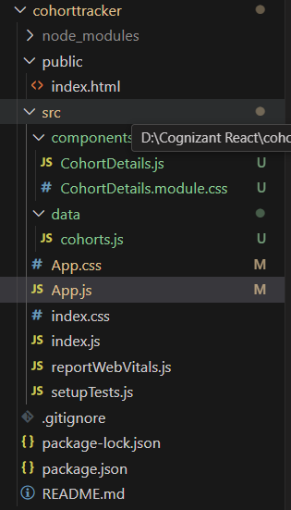

**Code –**

*CohortDetails.js –*

import React from 'react';

import styles from './CohortDetails.module.css';

function CohortDetails({ cohort }) {

  const titleColor = cohort.status === 'Ongoing' ? 'green' : 'blue';

  return (

    <div className={styles.box}>

      <h3 style={{ color: titleColor }}>

        {cohort.id} - {cohort.name}

      </h3>

      <dl>

        <dt>Started On</dt>

        <dd>{cohort.startDate}</dd>

        <dt>Current Status</dt>

        <dd>{cohort.status}</dd>

        <dt>Coach</dt>

        <dd>{cohort.coach}</dd>

        <dt>Trainer</dt>

        <dd>{cohort.trainer}</dd>

      </dl>

    </div>

  );

}

export default CohortDetails;

*cohorts.js –*

const cohorts = [

  {

    id: 'INTADMDF10',

    name: '.NET FSD',

    status: 'Scheduled',

    startDate: '22-Feb-2022',

    coach: 'Aathma',

    trainer: 'Jojo Jose'

  },

  {

    id: 'ADM21JF014',

    name: 'Java FSD',

    status: 'Ongoing',

    startDate: '10-Sep-2021',

    coach: 'Apoorv',

    trainer: 'Elisa Smith'

  },

  {

    id: 'CDBJF21025',

    name: 'Java FSD',

    status: 'Ongoing',

    startDate: '24-Dec-2021',

    coach: 'Aathma',

    trainer: 'John Doe'

  }

];

export default cohorts;

*cohortDetails.module.css –*

.box {

  width: 300px;

  display: inline-block;

  margin: 10px;

  padding: 10px 20px;

  border: 1px solid black;

  border-radius: 10px;

  box-shadow: 0 2px 6px rgba(0, 0, 0, 0.1);

  background-color: #fff;

}

dt {

  font-weight: 500;

}

*App.js –*

import React from 'react';

import CohortDetails from './components/CohortDetails';

import cohorts from './data/cohorts';

function App() {

  return (

    <div>

      <h2>Cohorts Details</h2>

      {cohorts.map((cohort) => (

        <CohortDetails key={cohort.id} cohort={cohort} />

      ))}

    </div>

  );

}

export default App;

**Output –**



